TURNICHET

UNIVERSITATEA POLITEHNICA BUCURESTI

FACULTATEA DE AUTOMATICA SI CALCULATOARE

2019-2020

PROIECT REALIZAT DE: PETRUC Rares

GRUPA: 312CD

PROFESOR DOCTOR COORDONATOR: Costin CHIRU

Cuprins

**Tema proiectului3**

**Descrierea modului de implementare3**

**Functionalitatea aparatului3**

**Organigrama aparatului5**

**Spatiul starilor6**

**Tabelul tranzitiilor6**

**Diagramele de stare pentru starea urmatoare si ecuatiile rezultate7**

**Diagramele Karnaugh si ecuatii rezultate pentru intrarile CBB-urilor10**

**Implementarea circuitului13**

**Tema proiectului**

Tema aleasa prezinta functionarea unui turnichet, destinat statiilor de metrou. Turnichetul prezentat nu ofera rest, insa pe langa verificarea si validarea cartelei de calatorii, acesta prezinta si optiunea de reincarcare a cartelei. Fiecare cartela, in valoare de 5 lei, contine 2 calatorii.

Aparatul primeste doar monede de 50 de bani si bancnote de 1 sau 5 lei.

**Mod de implementare**

CAM

CHECK

ACTIV

MECANISM TURNICHET

+

DISPLAY

DES

**Semnale din schema:**

ASM

WANT?

METHOD

FUNDS1

FUNDS

T_O

**Functionarea aparatului**

Aparatul se afla in sleep mode pana cand se introduce cartela de calatorii in turnichet. Ulterior, validatorul verifica existenta calatoriilor pe cartela. In cazul in care exista cel putin o calatorie, se va trimite un semnal de deschidere a portii spre turnichet, aceasta deschizandu-se numai daca, camera cu sensor de miscare detecteaza o persoana in apropierea portii.

In cazul in care calatoriile lipsesc de pe cartela, exista optiunea pentru calator de a-si achizitiona calatorii sau nu. Daca acesta doreste sa cumpere calatorii, va avea optiunea de a alege intre plata cash sau card. Daca opteaza pentru cash, are un timp de 15 secunde pentru a introduce orice moneda/bancnota permisa in aparat, iar in cazul in care o face, aparatul ramane blocat pana primeste restul banilor pana la suma de 5 lei (pretul unei cartele cu 2 calatorii). Daca se opteaza pentru card, se verifica existenta fondurilor necesare achitarii cartelei, iar ulterior, in functie de rezultat, se va ajunge in starea ulterioara transmiterii semnalului de deschidere a portii, sau se va reveni in starea de sleep a aparatului.

* ACTIV – este 1 daca se introduce cartela cu calatorii;
* CHECK – este 1 daca exista calatorii pe cartela; acesta si reduce numarul calatoriilor de pe o cartela (de exemplu daca la introducere in aparat, pe cartela erau doua calatorii, dupa validare, ramane una singura);
* WANT? – este 1 daca se doreste achizitionarea de calatorii;
* METHOD? – este 1 pentru plata cu cardul si 0 pentru plata cash; (prescurtat METH)
* FUNDS – este 1 daca exista fonduri pentru achitarea calatoriei;
* FUNDS1 – este 1 daca s-au introdus toti banii si 0 daca s-au introdus doar o parte din acestia( parte != 0); mai jos se afla o interpretare in C a lui FUNDS1 (wait in program).
* CAM – este 1 daca se detecteaza o persoana in apropierea turnichetului.

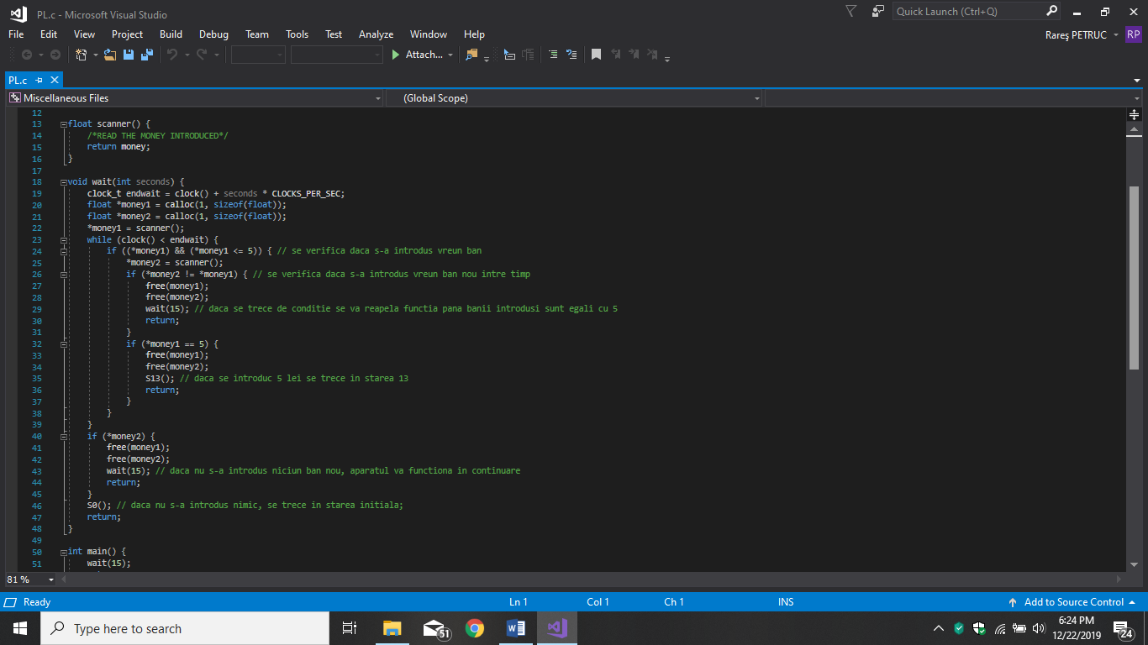

**Iesiri:**

* Y0  - “Ati introdus cartela. Asteptati!”;
* Y1  - “Nu mai aveti calatorii. Doriti sa achizitionati?”;
* Y2  - “Alegeti metoda de plata!”;
* Y3 - “Introduceti banii”;
* Y4  - “Introduceti cardul”;
* Y5 - “Plata a fost efecutata cu succes! Calatorie placuta!”;
* DES – “Validare efectuata! Calatorie placuta!” + semnal de deschidere catre poarta;

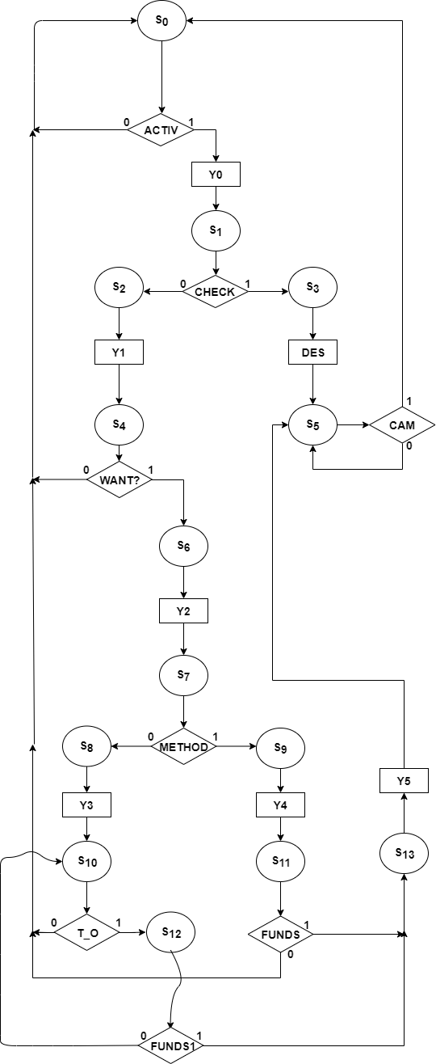

**Organigrama**

**aparatului**

0011

1010

1110

0001

1111

0101

1101

1001

0010

1000

1100

0110

0100

0000

|  |  |  |  |  |
| --- | --- | --- | --- | --- |
| Q3Q2  Q1Q0 | 00 | 01 | 11 | 10 |
| 00 | **S0** | **S1** | **S2** | **S4** |
| 01 | **S10** | **S8** | **S7** | **S6** |
| 11 | **S12** |  | **S9** |  |
| 10 | **S5** | **S3** | **S11** | **S13** |

**Spatiul starilor**

**Tabelul tranzitiilor**

|  |  |  |  |  |  |  |  |  |  |  |  |  |  |  |
| --- | --- | --- | --- | --- | --- | --- | --- | --- | --- | --- | --- | --- | --- | --- |
| Q3 | Q2 | Q1 | Q0 | Q3 | Q2 | Q1 | Q0 | Y0 | Y1 | Y2 | Y3 | Y4 | Y5 | DES |
| 0 | 0 | 0 | 0 | 0 | ACTIV | 0 | 0 | ACTIV | 0 | 0 | 0 | 0 | 0 | 0 |
| 0 | 0 | 0 | 1 | 0 | 0 | T_O | T_O | 0 | 0 | 0 | 0 | 0 | 0 | 0 |
| 0 | 0 | 1 | 0 | 0 | 0 | !CAM | 0 | 0 | 0 | 0 | 0 | 0 | 0 | 0 |
| 0 | 0 | 1 | 1 | FUNDS1 | 0 | FUNDS1 | !FUNDS1 | 0 | 0 | 0 | 0 | 0 | 0 | 0 |
| 0 | 1 | 0 | 0 | !CHECK | 1 | CHECK | 0 | 0 | 0 | 0 | 0 | 0 | 0 | 0 |
| 0 | 1 | 0 | 1 | 0 | 0 | 0 | 1 | 0 | 0 | 0 | 1 | 0 | 0 | 0 |
| 0 | 1 | 1 | 0 | 0 | 0 | 1 | 0 | 0 | 0 | 0 | 0 | 0 | 0 | 1 |
| 0 | 1 | 1 | 1 | * | * | * | * | * | * | * | * | * | * | * |
| 1 | 0 | 0 | 0 | WANT? | 0 | 0 | WANT? | 0 | 0 | 0 | 0 | 0 | 0 | 0 |
| 1 | 0 | 0 | 1 | 1 | 1 | 0 | 1 | 0 | 0 | 1 | 0 | 0 | 0 | 0 |
| 1 | 0 | 1 | 0 | 0 | 0 | 1 | 0 | 0 | 0 | 0 | 0 | 0 | 1 | 0 |
| 1 | 0 | 1 | 1 | * | * | * | * | * | * | * | * | * | * | * |
| 1 | 1 | 0 | 0 | 1 | 0 | 0 | 0 | 0 | 1 | 0 | 0 | 0 | 0 | 0 |
| 1 | 1 | 0 | 1 | METHOD | 1 | METHOD | 1 | 0 | 0 | 0 | 0 | 0 | 0 | 0 |
| 1 | 1 | 1 | 0 | FUNDS | 0 | FUNDS | 0 | 0 | 0 | 0 | 0 | 0 | 0 | 0 |
| 1 | 1 | 1 | 1 | 1 | 1 | 1 | 0 | 0 | 0 | 0 | 0 | 1 | 0 | 0 |

|  |  |  |  |  |
| --- | --- | --- | --- | --- |
| Q3Q2  Q1Q0 | 00 | 01 | 11 | 10 |
| 00 | 0 | !CHECK | 1 | WANT? |
| 01 | 0 | 0 | METH | 1 |
| 11 | FUNDS1 | * | 1 | * |
| 10 | 0 | 0 | FUNDS | 0 |

**Diagramele Karnaugh pentru starea urmatoare si iesiri**

Q3t+1 = Q3Q2!Q1!Q0 +Q3!Q2Q0 + Q3Q1Q0 + !CHECKQ2!Q1!Q0 + WANT?Q3!Q1!Q­0 + METHQ3Q0 + FUNDS1Q1Q0 + FUNDSQ3Q2Q1

|  |  |  |  |  |
| --- | --- | --- | --- | --- |
| Q3Q2  Q1Q0 | 00 | 01 | 11 | 10 |
| 00 | ACTIV | 1 | 0 | 0 |
| 01 | 0 | 0 | 1 | 1 |
| 11 | 0 | * | 1 | * |
| 10 | 0 | 0 | 0 | 0 |

|  |  |  |  |  |
| --- | --- | --- | --- | --- |
| Q3Q2  Q1Q0 | 00 | 01 | 11 | 10 |
| 00 | 0 | CHECK | 0 | 0 |
| 01 | T_O | 0 | METH | 0 |
| 11 | FUNDS1 | * | 1 | * |
| 10 | !CAM | 1 | FUNDS | 1 |

|  |  |  |  |  |
| --- | --- | --- | --- | --- |
| Q3Q2  Q1Q0 | 00 | 01 | 11 | 10 |
| 00 | 0 | 0 | 0 | WANT? |
| 01 | T_O | 1 | 1 | 1 |
| 11 | !FUNDS1 | * | 0 | * |
| 10 | 0 | 0 | 0 | 0 |

Q0t+1 = Q3!Q1Q0 + !Q3Q2Q0 + WANT?Q3!Q2!Q1 + T_O!Q1Q0 + !FUNDS1!Q3Q1Q0

Q1t+1 = !Q3Q2Q1 + Q2Q1Q0 + Q3!Q2Q1 + CHECK!Q3Q2!Q0 + T_O!Q3!Q2!Q1Q0 + METHQ3Q2Q0 + FUNDS1Q1Q0 + !CAM!Q3Q1!Q0 + FUNDSQ3Q1

Q2t+1 = !Q3Q2!Q1!Q0 + Q­­3Q0 + ACTIV!Q3!Q1!Q0

Y0t+1 = ACTIV!Q3!Q2!Q1!Q0

Y1t+1 = Q3Q2!Q1!Q0

|  |  |  |  |  |
| --- | --- | --- | --- | --- |
| Q3Q2  Q1Q0 | 00 | 01 | 11 | 10 |
| 00 | ACTIV | 0 | 0 | 0 |
| 01 | 0 | 0 | 0 | 0 |
| 11 | 0 | * | 0 | * |
| 10 | 0 | 0 | 0 | 0 |

|  |  |  |  |  |
| --- | --- | --- | --- | --- |
| Q3Q2  Q1Q0 | 00 | 01 | 11 | 10 |
| 00 | 0 | 0 | 1 | 0 |
| 01 | 0 | 0 | 0 | 0 |
| 11 | 0 | * | 0 | * |
| 10 | 0 | 0 | 0 | 0 |

Y2t+1 = Q3!Q2Q0

|  |  |  |  |  |
| --- | --- | --- | --- | --- |
| Q3Q2  Q1Q0 | 00 | 01 | 11 | 10 |
| 00 | 0 | 0 | 0 | 0 |
| 01 | 0 | 0 | 0 | 1 |
| 11 | 0 | * | 0 | * |
| 10 | 0 | 0 | 0 | 0 |

|  |  |  |  |  |
| --- | --- | --- | --- | --- |
| Q3Q2  Q1Q0 | 00 | 01 | 11 | 10 |
| 00 | 0 | 0 | 0 | 0 |
| 01 | 0 | 1 | 0 | 0 |
| 11 | 0 | * | 0 | * |

|  |  |  |  |  |
| --- | --- | --- | --- | --- |
| 10 | 0 | 0 | 0 | 0 |

Y3t+1 = !Q3Q2Q0

|  |  |  |  |  |
| --- | --- | --- | --- | --- |
| Q3Q2  Q1Q0 | 00 | 01 | 11 | 10 |
| 00 | 0 | 0 | 0 | 0 |
| 01 | 0 | 0 | 0 | 0 |
| 11 | 0 | * | 1 | * |
| 10 | 0 | 0 | 0 | 0 |

|  |  |  |  |  |
| --- | --- | --- | --- | --- |
| Q3Q2  Q1Q0 | 00 | 01 | 11 | 10 |
| 00 | 0 | 0 | 0 | 0 |
| 01 | 0 | 0 | 0 | 0 |
| 11 | 0 | * | 0 | * |
| 10 | 0 | 0 | 0 | 1 |

|  |  |  |  |  |
| --- | --- | --- | --- | --- |
| Q3Q2  Q1Q0 | 00 | 01 | 11 | 10 |
| 00 | 0 | 0 | 0 | 0 |
| 01 | 0 | 0 | 0 | 0 |
| 11 | 0 | * | 0 | * |
| 10 | 0 | 1 | 0 | 0 |

Y4t+1 = Q3Q1Q0

DESt+1 = !Q3Q2Q1

Y5t+1 = Q3!Q2Q1

**Diagramele Karnaugh si ecuatiile rezultate pentru intrarile CBB-urilor**

J3 = !CHECKQ2!Q1!Q­­­0 + FUNDS1Q1Q0

|  |  |  |  |  |
| --- | --- | --- | --- | --- |
| Q3Q2  Q1Q0 | 00 | 01 | 11 | 10 |
| 00 | 0 | !CHECK | * | * |
| 01 | 0 | 0 | * | * |
| 11 | FUNDS1 | * | * | * |
| 10 | 0 | 0 | * | * |

Q2

Q3

|  |  |  |  |  |
| --- | --- | --- | --- | --- |
| Q3Q2  Q1Q0 | 00 | 01 | 11 | 10 |
| 00 | * | * | 0 | !WANT? |
| 01 | * | * | !METH | 0 |
| 11 | * | * | 0 | * |
| 10 | * | * | !FUNDS | 1 |

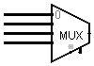

FUNDS 1Q1Q0

!CHECK!Q1!Q0

K3 = !Q2Q1 + !WANT?!Q­2!Q0 + !METHQ2!Q1Q­0 + !FUNDSQ1!Q0

0

1

0

!FUNDS

!METH

!WANT?

0

0

Q0-

Q2

Q1

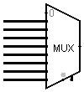

0UNDS1

0

|  |  |  |  |  |
| --- | --- | --- | --- | --- |
| Q3Q2  Q1Q0 | 00 | 01 | 11 | 10 |
| 00 | 0 | 0 | 0 | WANT? |
| 01 | T_O | 1 | 1 | 1 |
| 11 | !FUNDS1 | * | 0 | * |
| 10 | 0 | 0 | 0 | 0 |

|  |  |  |  |  |
| --- | --- | --- | --- | --- |
| Q3Q2  Q1Q0 | 00 | 01 | 11 | 10 |
| 00 | 0 | CHECK | 0 | 0 |
| 01 | T_O | 0 | METH | 0 |
| 11 | * | * | * | * |
| 10 | * | * | * | * |

Q­2Q0 + T_O!Q1Q0 + FUNDS1Q1Q0

!Q1Q0 + WANT?!Q2!Q1

Q3



D0 = Q0t+1 = Q3!Q1Q0 + !Q3Q2Q0 + WANT?Q3!Q2!Q1 + T_O!Q1Q0 + !FUNDS1!Q3Q1Q0

|  |  |  |  |  |
| --- | --- | --- | --- | --- |
| Q3Q2  Q1Q0 | 00 | 01 | 11 | 10 |
| 00 | * | * | * | * |
| 01 | * | * | * | * |
| 11 | !FUNDS1 | * | 0 | * |
| 10 | CAM | 0 | !FUNDS | 0 |

K1 = !FUNDS1!Q2Q0 + CAM!Q3!Q2!Q0 + !FUNDSQ3Q2!Q0

J1 = CHECK!Q3Q2!Q0 + T_O!Q3!Q2Q0 + METHQ3Q2Q0

|  |  |  |  |  |
| --- | --- | --- | --- | --- |
| Q3Q2  Q1Q0 | 00 | 01 | 11 | 10 |
| 00 | ACTIV | 1 | 0 | 0 |
| 01 | 0 | 0 | 1 | 1 |
| 11 | 0 | * | 1 | * |
| 10 | 0 | 0 | 0 | 0 |

D2 = Q2t+1 = !Q3Q2!Q1!Q0 + Q­­3Q0 + ACTIV!Q3!Q1!Q0

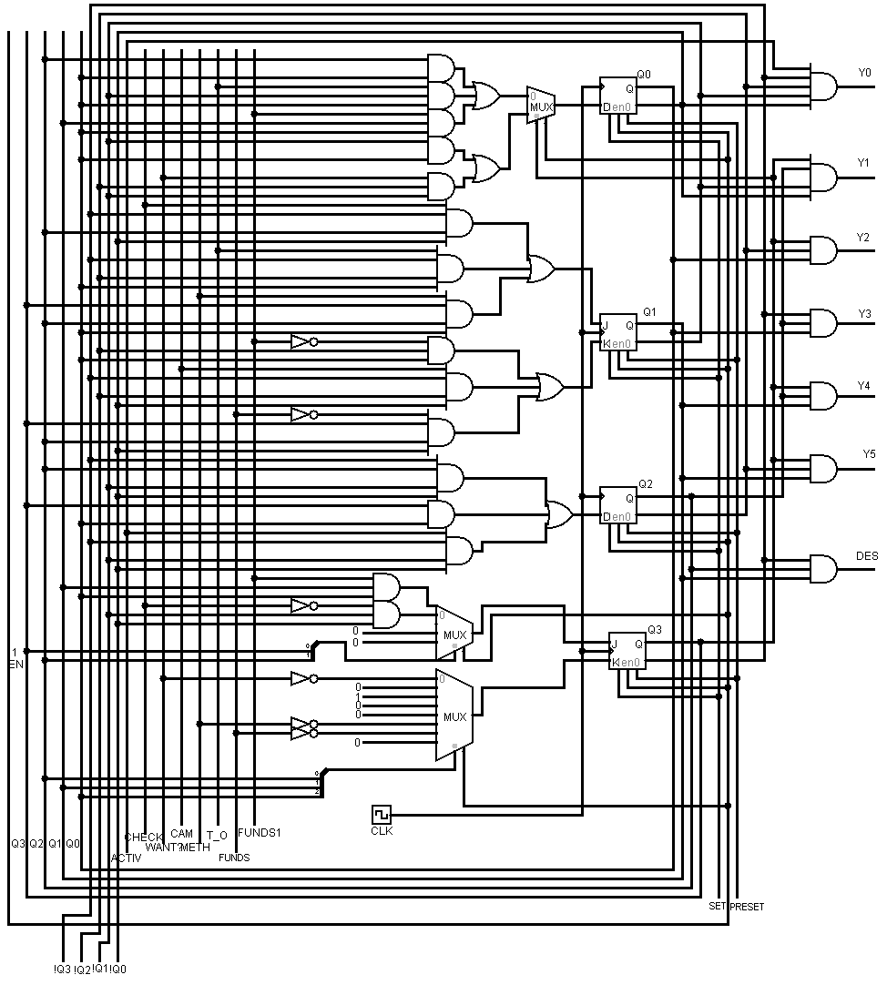

**Implementarea circuitului**